Exercise
- Console "Hello Word" in document.ready function
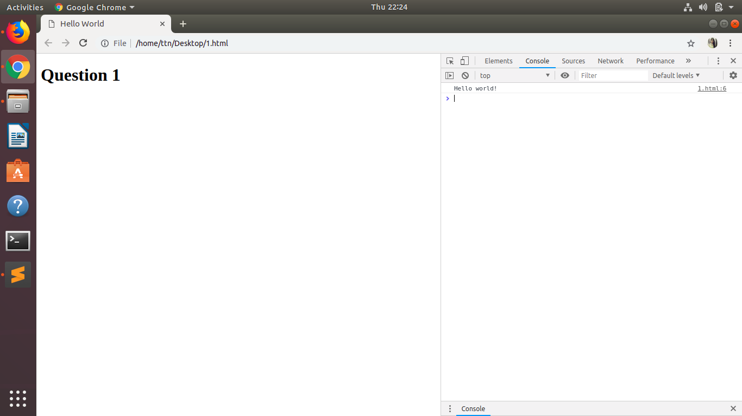

- Select a ID name "#test" and add class "load" when DOM is loaded

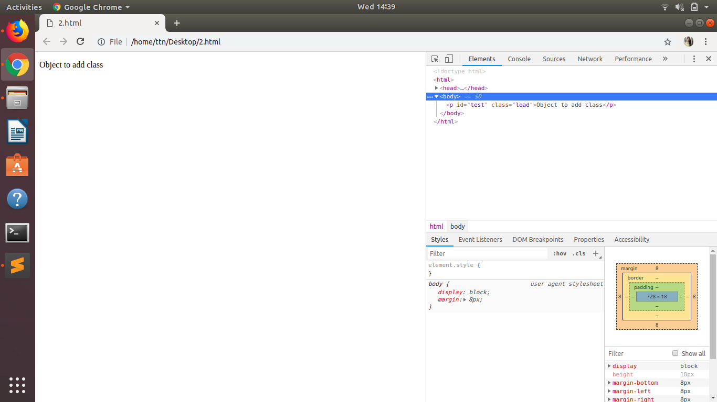

- Change the color of element which class name end with "-new"
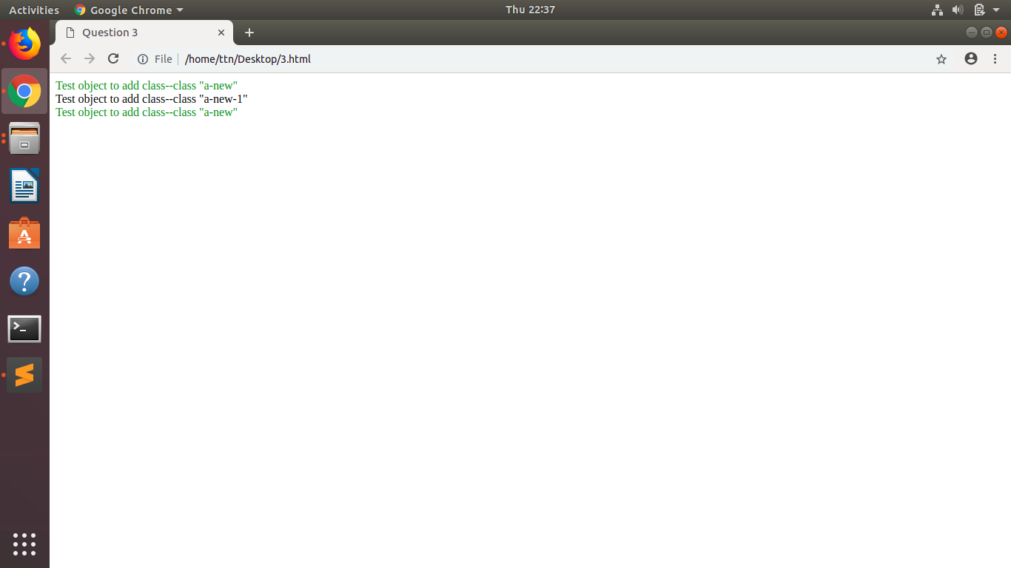

- Disable submit button using jquery attr method
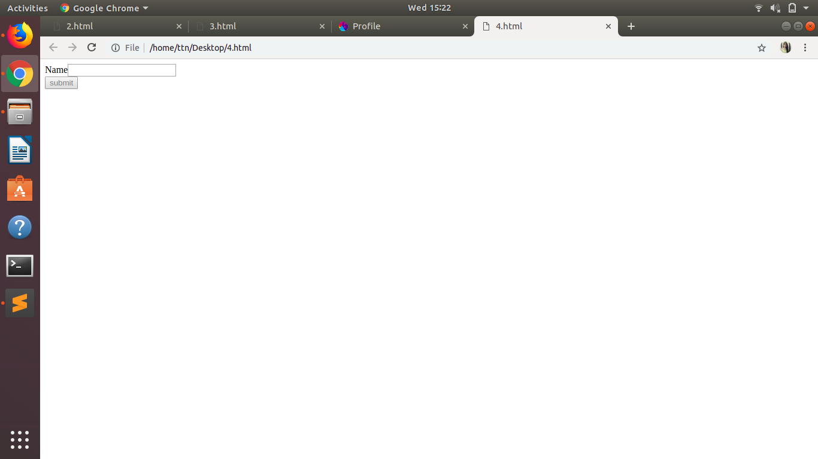

- Change the font size of ".target" which has parent element with id name "#main"
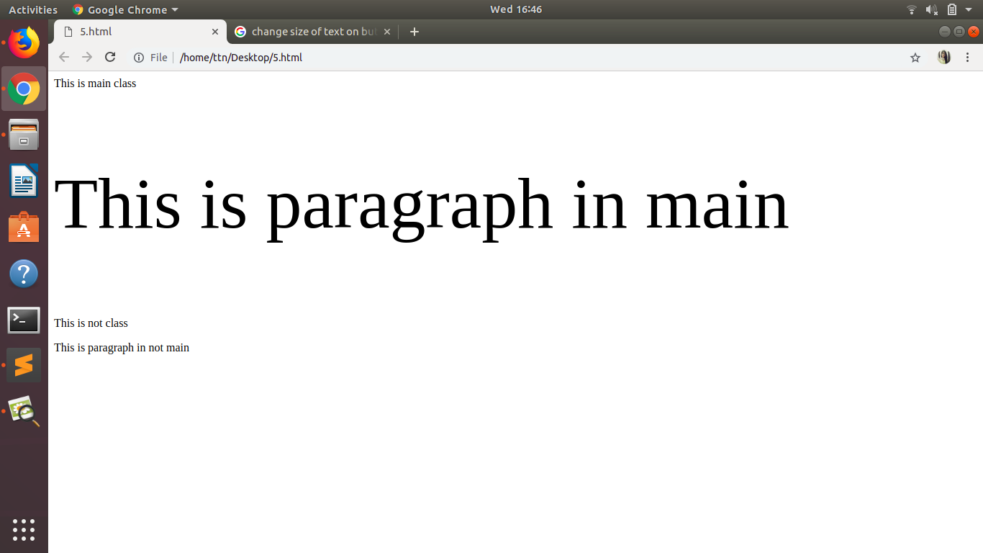

- After page load change the HTML of div element with "p" element
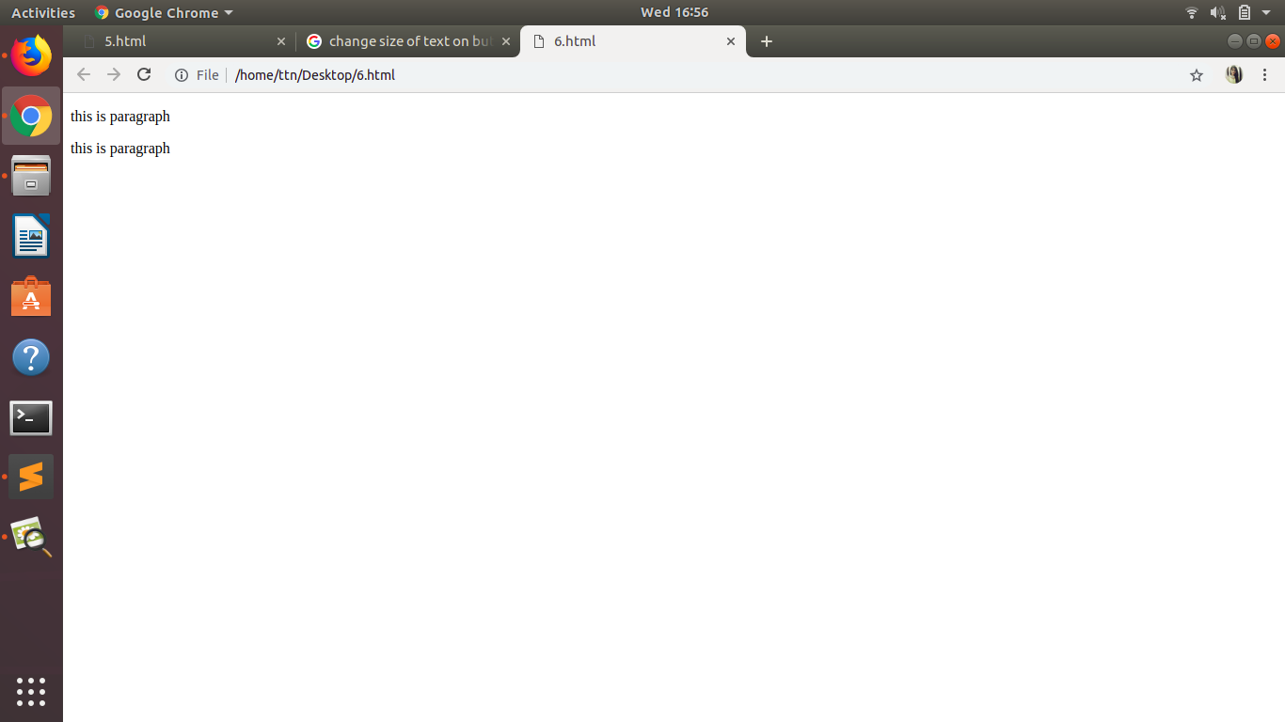

- Bind a click function to an "click" element and append next "click" next to it.
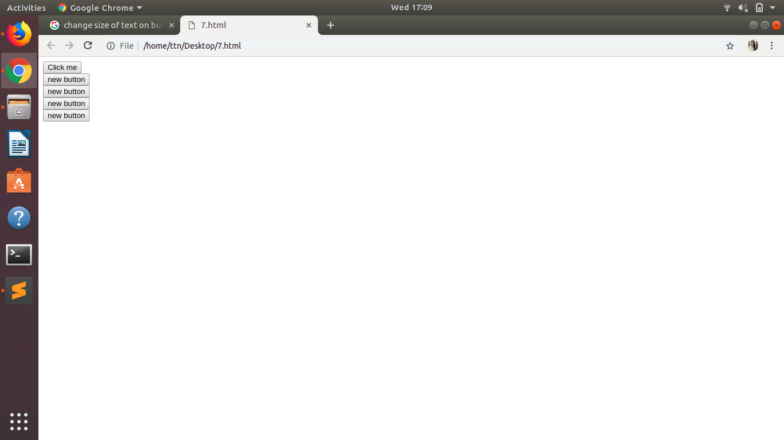

- Click event not working on element which added dynamicly or via script, make it work using .on method
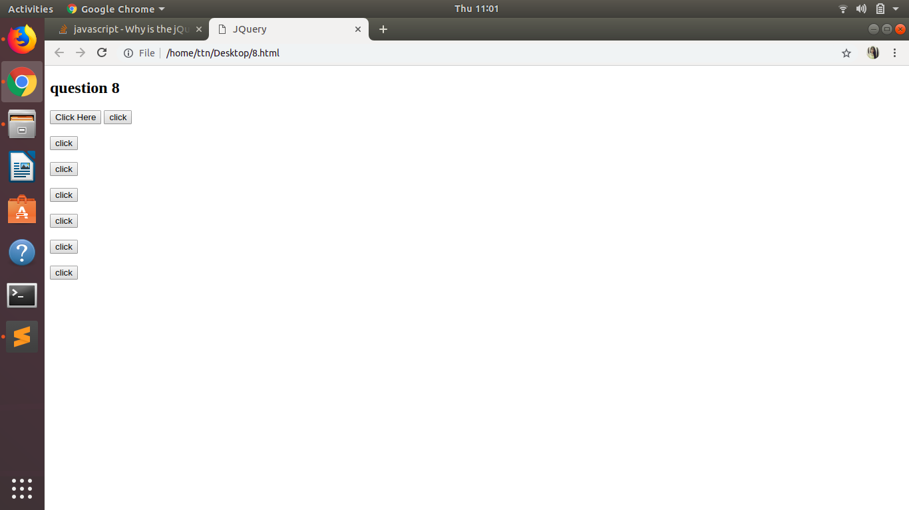

- Get dropdown selected value on onchanage event and append in div container
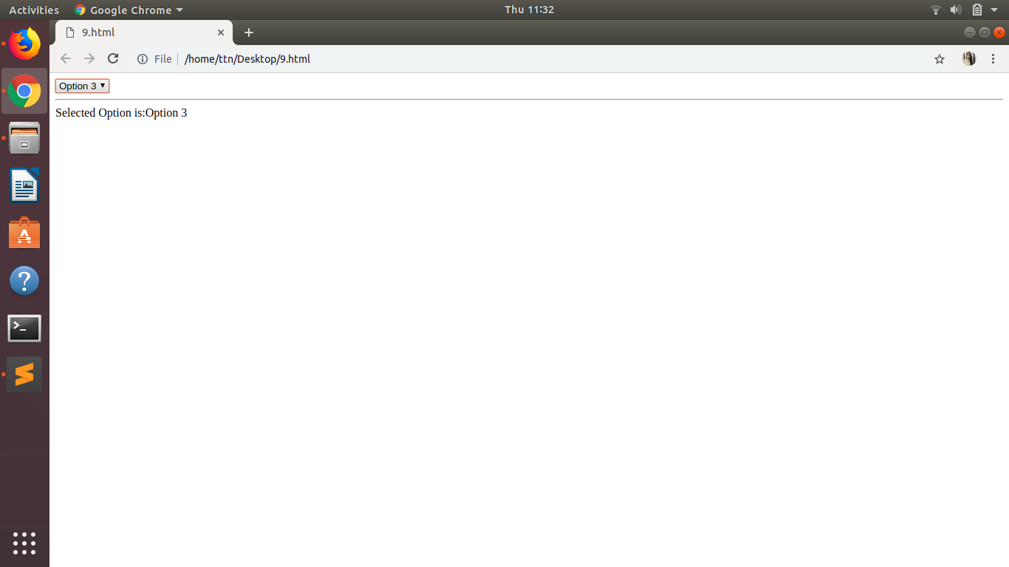

- Create a dropdown menu using hover method in jquery
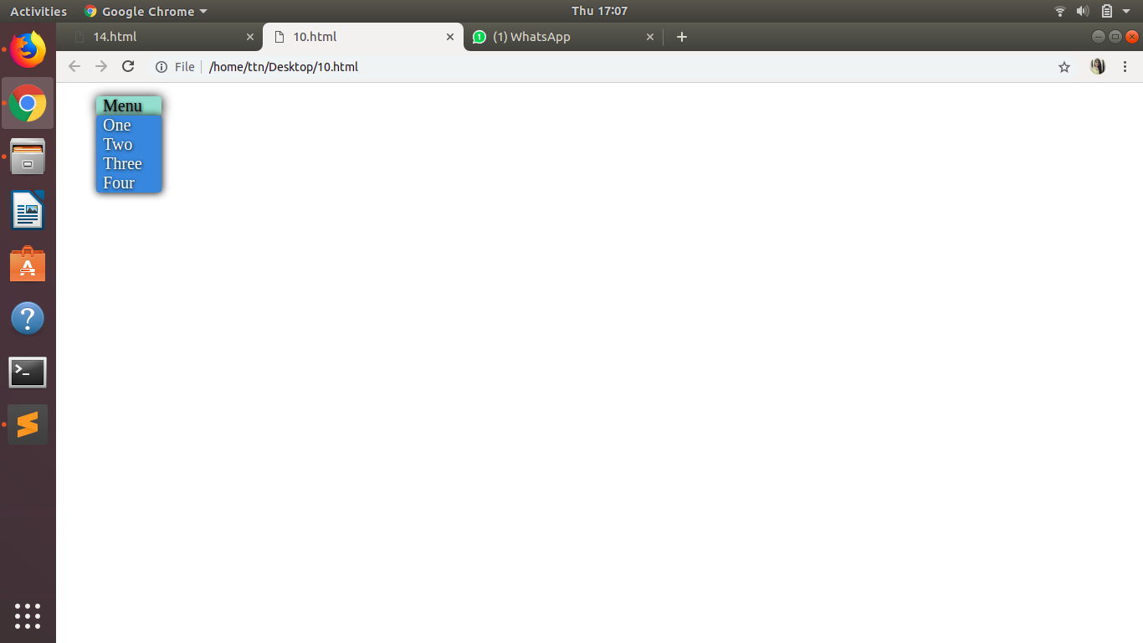

- On clicking on "google" tag. It is taking us to google home page. Stop it from happening.
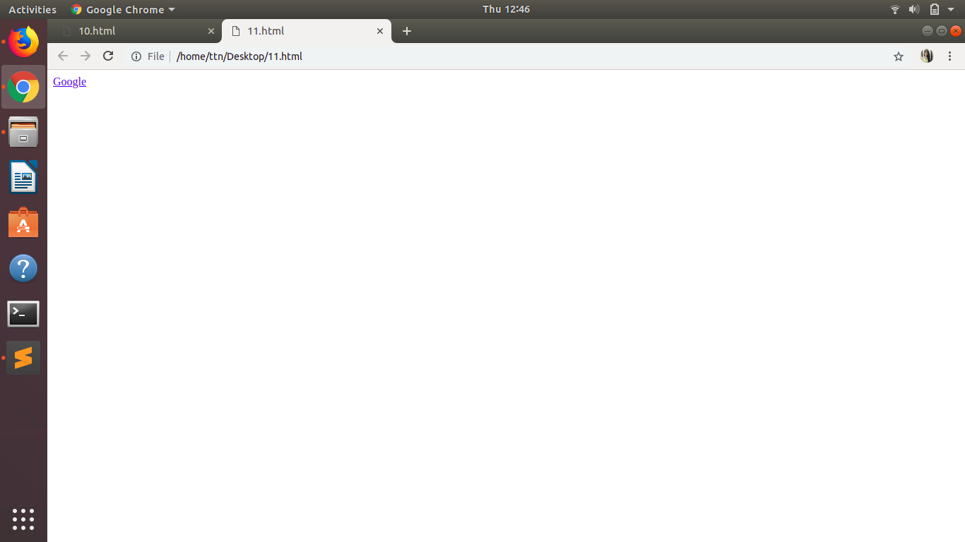

- We have bind a click funtion to parent div but we want stop it from performing when user clicks on its child li

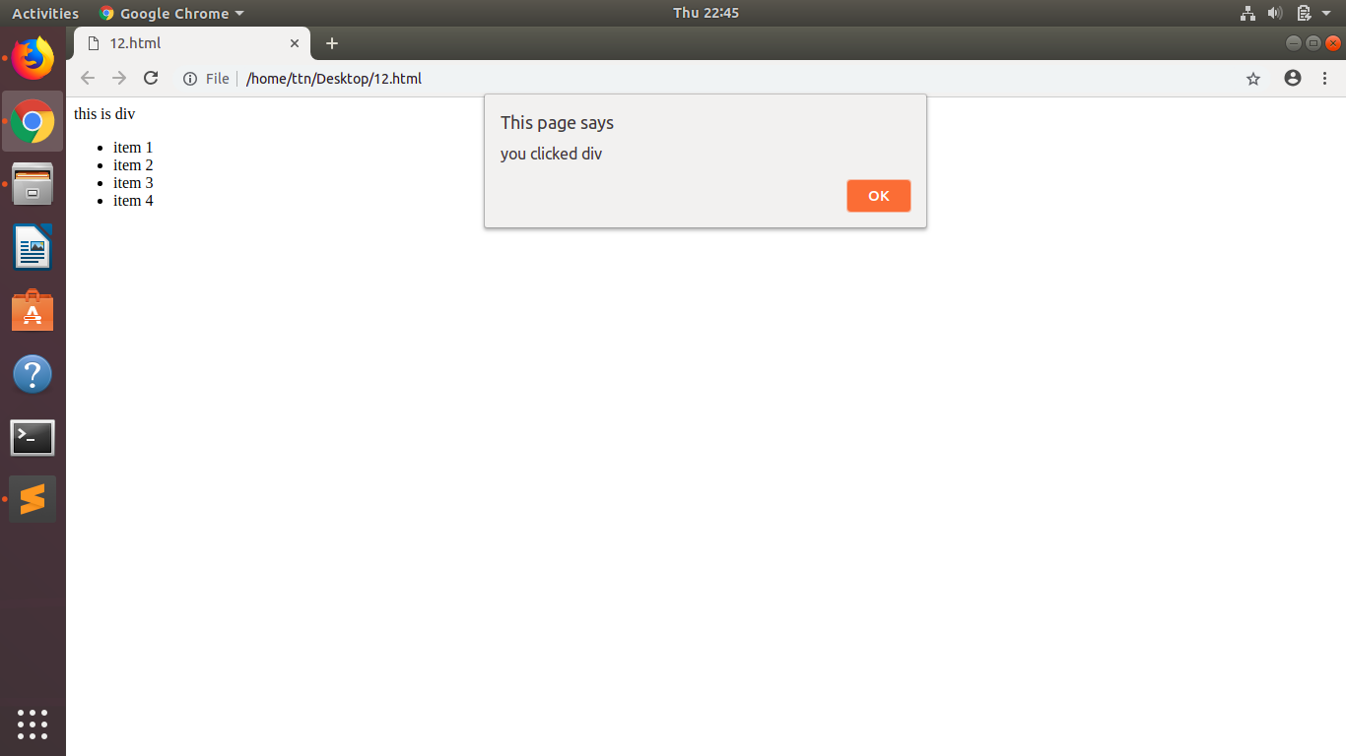

- Get the max height of elements using jquery each method
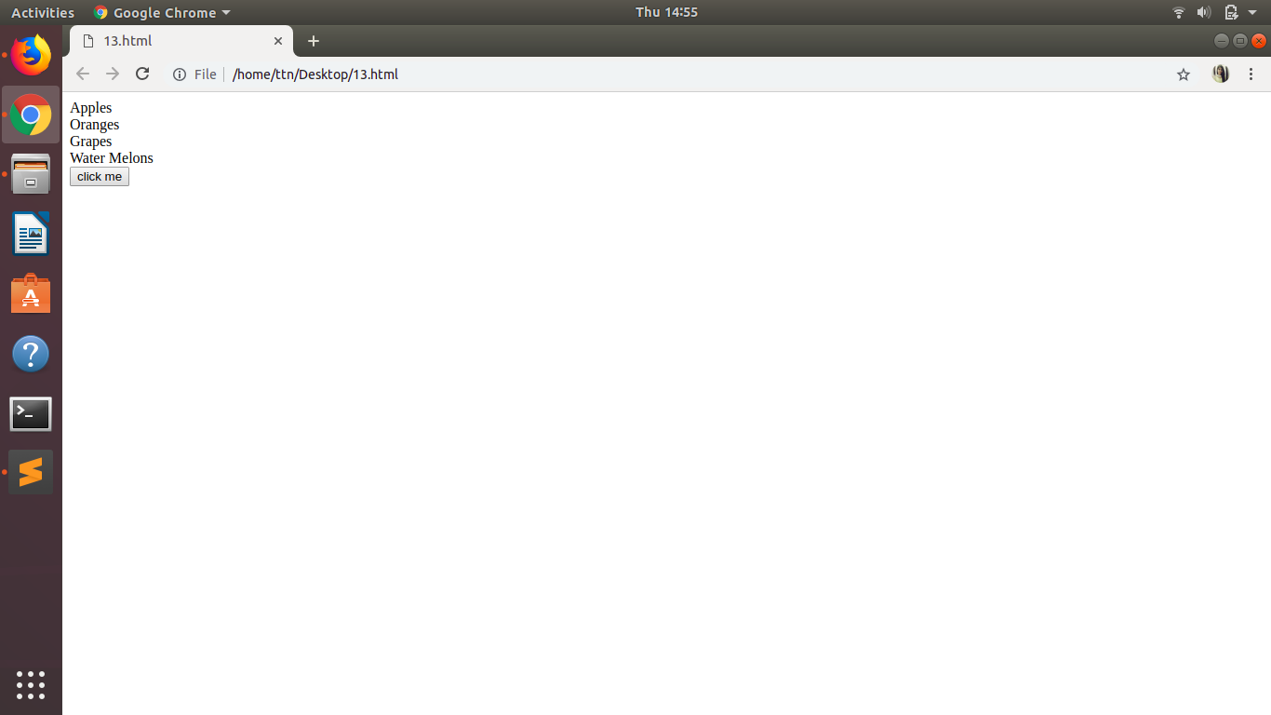

- Change color of every cell which has numberl larger than 10.
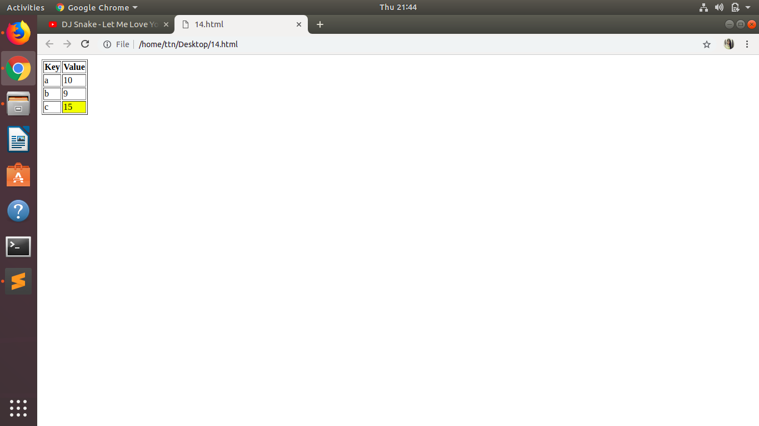

- Retrive the data from server using ajax get call
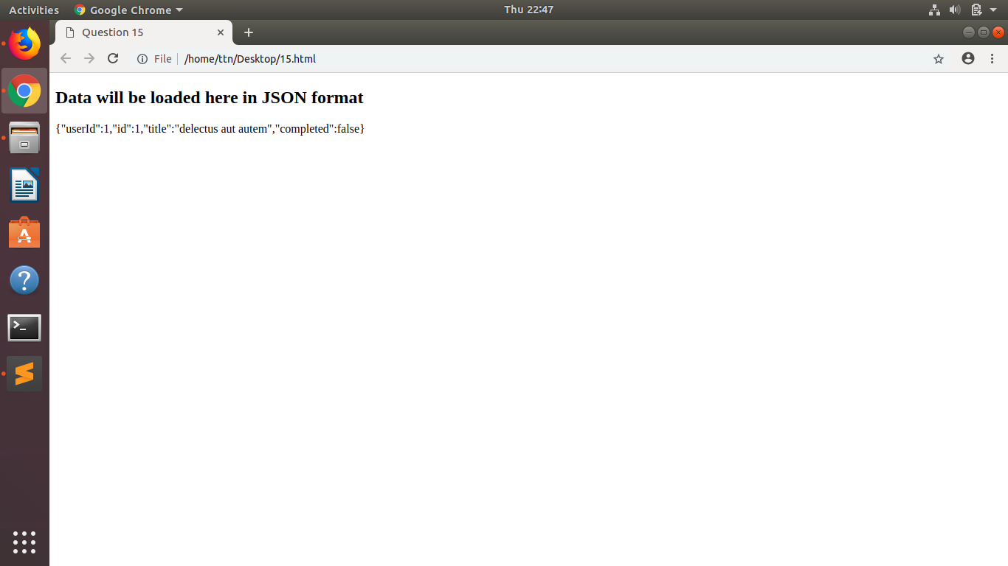

- Add cross button on row and bind click function which make a delete request to server, after success event remove the row from dom
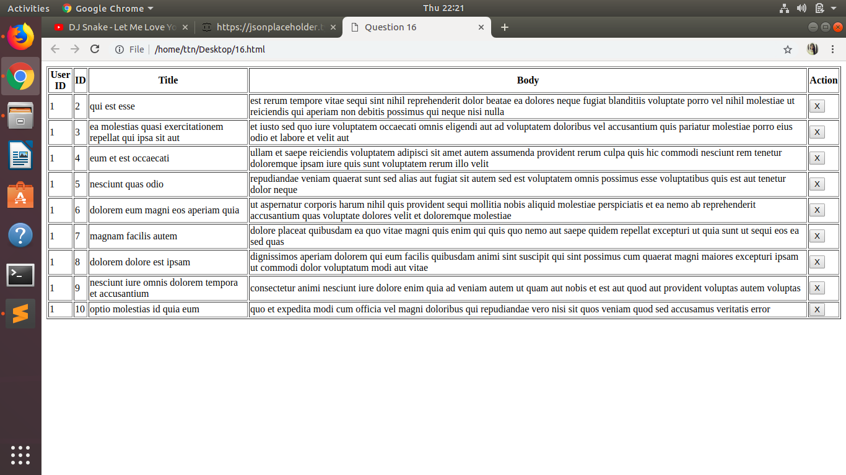

- Create a image array and in div create a slide show to animate images of delay of 500ms.
